Elimination of centrioles

Jaba Tkemaladze¹
¹ Research Director, Longevity Clinic Georgia Inc. jtkemaladze@longevity.ge

Abstract
Centrioles, microtubule-based cylindrical structures, are pivotal for generating centrosomes, cilia, flagella, and somatic cells differentiation thereby supporting essential cellular functions such as motility, signaling, and tissue development. While known for their durability and ability to persist through multiple cell cycles, centrioles can undergo selective elimination under certain biological contexts. We have expanded our understanding of centriole dynamics, shedding light on the processes that regulate their assembly, stability, and eventual removal. This review examines diverse examples of centriole elimination across species and cell types, exploring the mechanisms that enable this transition from a stable organelle to a transient structure. Further insights into these processes could unlock new avenues for manipulating centriole behavior, with implications for both health and disease.

Keywords: centriole, centrosome, elimination, differentiation, development, oogenesis, spermatogenesis, Hayflick, aging

Introduction

Centrioles are conserved organelles central to cellular architecture and function. Their stability allows them to contribute to key processes such as cellular signaling, differentiation, and movement. However, under specific circumstances, centrioles can be actively degraded, a phenomenon first noted by Theodor Boveri during his studies on oocytes. Since then, centriole elimination has been identified in various systems, but its regulatory mechanisms remain incompletely understood.

Centrioles are cylindrical microtubule-based structures, typically measuring around 500 nm in length and 250 nm in diameter, located near the nucleus in cycling cells. In many differentiated cells, centrioles function as basal bodies that anchor and organize the axoneme of primary or motile cilia and flagella, playing a vital role in signal transduction and cellular motility. In cycling animal cells, centrioles, together with the pericentriolar material (PCM), form centrosomes, which act as major microtubule-organizing centers (MTOCs). Centrosomes are indispensable for ensuring proper cellular organization during interphase and for directing bipolar spindle formation during mitosis, thereby supporting accurate chromosome segregation. Disruptions in centriole number or structure are associated with a variety of disorders, such as ciliopathies and cancer.

Centriole biogenesis is tightly controlled throughout the cell cycle. Initially, a mother centriole, distinguished by unique distal and subdistal appendages, is linked to a daughter centriole via a flexible linker. During the S phase, a new procentriole begins to form orthogonally to each existing centriole, eventually giving rise to a mature centriole pair. By early mitosis, the two centriole pairs separate and guide bipolar spindle formation. The molecular machinery regulating this centriole duplication cycle is highly intricate and well-studied. However, the mechanisms enabling centriole removal, while less explored, are now recognized as critical for understanding organelle dynamics and their roles in cellular homeostasis and pathology.

Assembly of Centrioles
The process of centriole formation is highly conserved across eukaryotes. Each daughter cell inherits one mature centriole (the "mother") and one recently formed centriole (the "daughter") from the preceding cell cycle. Mature centrioles can be distinguished by their distal and subdistal appendages, which form during the late G2 and M phases of the cell cycle. A crucial initial step in centriole biogenesis involves the assembly of a protein scaffold—a toroidal structure near the proximal region of existing centrioles. This scaffold is composed of proteins such as Cep152, Cep63, and Cep57, which help anchor Polo-like kinase 4 (Plk4), a critical regulator of centriole formation.

Plk4 accumulates on the torus and undergoes homodimerization, triggering self-phosphorylation. This step marks Plk4 for degradation via ubiquitination, although its interaction with STIL stabilizes it locally and prevents excessive turnover. Together, Plk4 and STIL recruit HsSAS-6, the key structural component of the centriole’s characteristic “cartwheel.” HsSAS-6 forms ninefold symmetric ring-like structures through its coiled-coil and head domains, which stack to create the foundation of the nascent centriole. This cartwheel structure connects to the emerging microtubule walls via a molecular complex referred to as the pinhead, thought to contain proteins like Cep135.

As the procentriole elongates, proteins such as CPAP, Cep120, and Poc1 ensure proper assembly and length regulation. Additional components, including Centrin, integrate into the centriole, particularly within its central core and distal regions, finalizing the formation of a functional centriole.

Centriole Elimination in Female Germ Cells
Advances in electron microscopy during the 1950s revealed the characteristic ninefold radial symmetry of centrioles, but further studies demonstrated that vertebrate oocytes lack these organelle. Early observations by Boveri highlighted centriole disappearance during oogenesis, a phenomenon now recognized as common among metazoans. However, the specifics of this process, including its timing and mechanisms, vary widely among species.

For instance, in organisms such as Xenopus laevis, Mus musculus, and Drosophila melanogaster, centrioles are eliminated during the prophase of meiosis I. This leads to acentriolar meiotic spindles. In Drosophila, oocyte maturation involves a cluster of centrioles transferred from surrounding nurse cells, which assist in mRNA and protein trafficking to the oocyte. These centrioles disassemble gradually, with their structural components and associated proteins being lost sequentially.

By contrast, species such as echinoderms and mollusks retain centrioles through oogenesis, with their removal occurring during meiotic divisions. In these systems, centrioles are often extruded into polar bodies, leaving a single centriole in the mature oocyte. For example, in Patiria miniata (starfish), the retained centriole is invariably a daughter centriole, while others are discarded.

An intermediate scenario occurs in species like the snail Lymnaea stagnalis, where a single centriole pair is inherited by the oocyte. This pair is sequentially eliminated through extrusion into polar bodies during meiosis, ensuring the absence of maternal centrioles in the embryo.

Centriole Dynamics in Male Germ Cells
Centriole reduction is not exclusive to oogenesis and is also observed during spermatogenesis. While sperm cells in many species contribute fully intact centrioles to the zygote, modifications and degradation of these organelles can occur. For example, in human sperm, the distal centriole responsible for flagellar axoneme formation degenerates, while the proximal centriole remains functional. In Drosophila, sperm carry a giant centriole and a degenerate proximal centriole-like structure. Although these structures lose many key proteins during maturation, they retain a subset of components necessary for centrosomal function post-fertilization.

Rodents exemplify the extreme of centriole reduction, where both centrioles disassemble entirely during spermatogenesis. Despite this, centriolar protein remnants persist as foci, ensuring minimal functional activity until de novo centriole formation resumes in early embryogenesis.

Challenges in Tracking Centriole Loss
The small size and transient nature of centrioles present significant challenges for their study. Although electron microscopy remains the gold standard for identifying centriole ultrastructure, many studies rely on the detection of centriolar protein foci as proxies. However, these foci do not always correlate with intact centrioles and may instead represent degraded or incomplete structures. Advances in high-resolution imaging techniques, such as expansion microscopy, offer new opportunities to verify the integrity and function of these elusive organelles. These examples underscore the diversity of centriole dynamics across species, highlighting the balance between structural degradation and functional retention during gametogenesis. The observed examples highlight that the presence of centriolar protein foci does not guarantee the existence of fully formed centrioles, even when these foci retain their ability to recruit pericentriolar material (PCM) and function as microtubule-organizing centers (MTOCs). This raises the possibility that during centriole elimination, remnants of centriolar protein complexes might persist, recruiting PCM despite the complete structural disassembly of centrioles. Advanced imaging techniques, such as expansion microscopy, now allow the visualization of the ninefold radial symmetry of centriolar microtubules, offering a higher-resolution tool to distinguish true centrioles from residual foci of centriolar proteins.
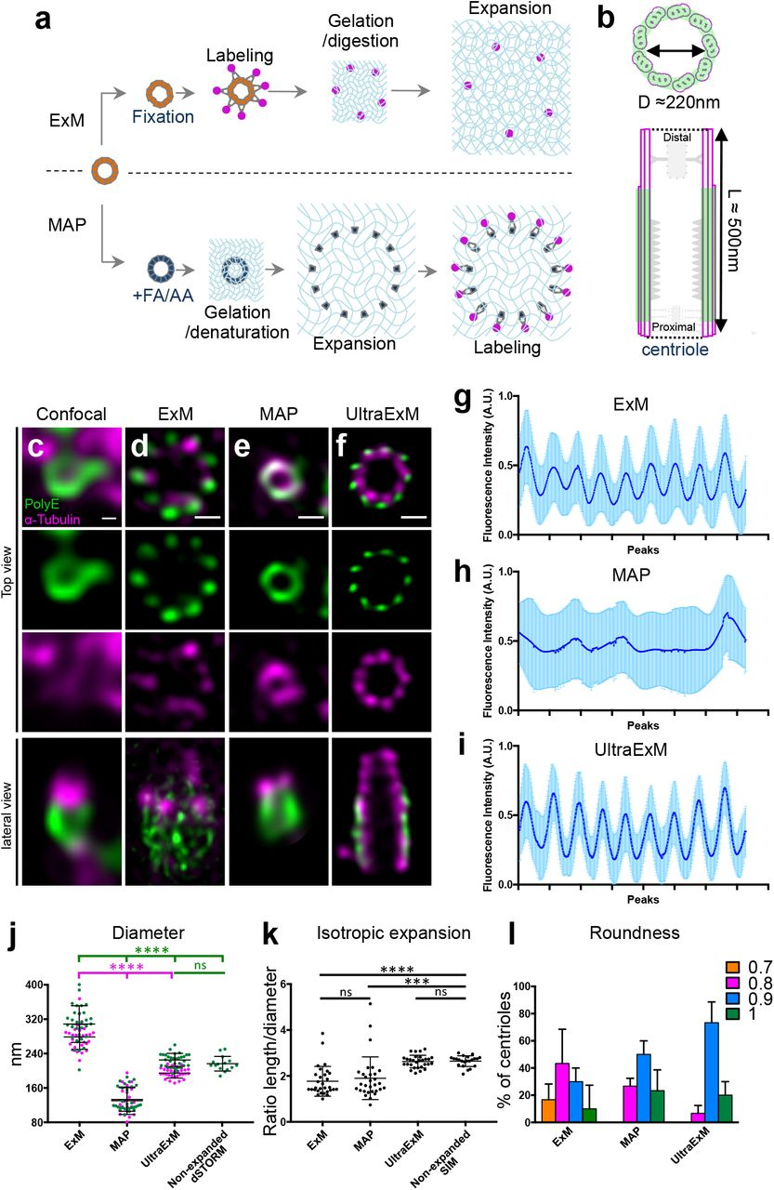
Figure 1. Centriole expansion using UltraExM. (a) Schematic illustration of two methods of expansion microscopy, ExM and MAP. (b) Schematic representation of a centriole seen either in top view (top) or lateral view (bottom), (c-f) Non-expanded (c) and expanded (d-f) isolated centrioles stained with PolyE (green, Alexa488) and α-tubulin (magenta, Alexa568) imaged by confocal microscopy followed by HyVolution. Centrioles were expanded using ExM (d), MAP (e) or UltraExM (f). Scale bar in c: 100nm and d-f: 450 nm, (g-i) Plot profile of the polar transform showing the 9-fold symmetry for ExM (g), MAP (h) and UltraExM (i). (j) Diameter of the centrioles in the different conditions. Green and magenta dots represent PolyE and α-tubulin diameters, respectively. PolyE: 308 nm ± 8 nm, 133 nm ± 5 nm, 225 nm ± 3 nm and 216 nm ± 4 for ExM, MAP, UltraExM and Nonexpanded dSTORM respectability. α-tubulin: 279 nm ± 5, 130 nm ± 7 nm and 195 ±2, for ExM, MAP and UltraExM respectability. (k) Isotropic expansion measured as the ratio between the centriolar length and diameter: ExM=1.8, MAP=1.9, UltraExM=2.6, Non-expanded SIM=2.6. (l) Roundness, shape of the centriole for the three expansion methods. ns=non significant, ***(P=0.0002), ****(P<0.0001). Note that for all the quantifications provided in this figure, we included data from UltraExM performed with 0.7%FA + 0.15% and 0.7%FA + 1% AA. (Gambarotto et al., 2018)

In rodents, the extreme reduction of centrioles during spermatogenesis results in their complete disintegration by the end of gametogenesis, though protein aggregates containing Centrin are retained. The absence of functional centrioles in both gametes leads to acentriolar cell divisions in the early embryonic stages, with de novo centriole formation occurring later during blastocyst development.

Prevalence of Centriole Elimination

Centriole elimination extends beyond germ cells and is frequently observed in differentiated somatic cells across various species. For instance, during terminal differentiation, centrioles are often removed in organisms such as C. elegans and Drosophila. In many cases, terminally differentiated cells harbor primary cilia, which are assembled using centrioles as basal bodies. However, certain cells, like sensory neurons in C. elegans, dismantle their centrioles after initiating ciliary axoneme formation, leaving only PCM components at the ciliary base. A comprehensive study of C. elegans embryogenesis revealed that centriole elimination occurs in approximately 88% of cells, in a programmed and lineage-specific manner. While most terminally differentiated cells lose their centrioles, some retain them if they have roles in future cell cycles or mitotic events. For example, intestinal cells maintain centrioles temporarily during endoreduplication cycles before eventually discarding them. Interestingly, even in cases where foci enriched in centriolar proteins are detected, the absence of structural centrioles has been confirmed in certain cells. Centriole elimination appears to correlate with processes like absence of differentiation, syncytium formation or polyploidization, seen in various cell types, including Drosophila nurse cells, salivary glands, and intestinal cells in C. elegans. However, this is not a universal rule. Some polyploid cells, such as mammalian trophoblast giant cells, retain centrioles or even amplify them, while other differentiated cells eliminate centrioles without undergoing polyploidization.

Mechanisms and Regulation of Centriole Elimination

The systematic elimination of centrioles in specific cell types suggests it is an active and tightly regulated process rather than a passive consequence. The process appears to involve three distinct phases: centriole maintenance, priming for elimination, and the execution phase, where structural and functional disassembly occurs. Not all cells exiting the cell cycle undergo centriole elimination, as evidenced by the retention of centrioles in many terminally differentiated cells that support cilia or flagella formation. Experiments in C. elegans have shown that altering the developmental fate of progenitor cells can switch their centriole status. For example, reprogramming a progenitor destined to form pharyngeal cells (which lack centrioles) into intestinal cells (which retain them) results in centriole maintenance. Conversely, preventing a cell's transdifferentiation to a fate associated with centriole loss allows centrioles to persist. These findings underscore that centriole elimination is intricately linked to the differentiation, specific fate and functional requirements of the cell. Centriole elimination is not limited to female gametes; it is a widespread process observed in diverse cell types that lack cilia or flagella.

Imperative

In oogenesis, centriole removal ensures accurate centriole inheritance in the zygote, which is crucial for proper bipolar spindle formation and accurate chromosome segregation. Retaining centrioles in the egg could lead to supernumerary centrioles in the zygote, causing tetrapolar spindle formation, chromosomal instability, and developmental arrest. This risk is underscored by studies in organisms like P. miniata and Drosophila, where experimental interference with centriole elimination causes spindle assembly defects, mitotic errors, and embryonic lethality. Moreover, centriole removal acts as a safeguard against parthenogenesis, as demonstrated in Xenopus, where introducing exogenous centrosomes can bypass this natural barrier, leading to parthenogenetic development. The absence of centriole elimination in male gametes likely reflects their functional necessity for flagellum formation during spermatogenesis, restricting evolutionary pathways for this process. However, alternative mechanisms of centriole inheritance at fertilization—such as dual gametic centriole contribution—remain a speculative avenue for future research, particularly in non-model organisms.

Potential Roles in Differentiated Somatic Cells

The rationale for centriole ablation in somatic cells remains less clear, but may serve to restore totipotency in the oocyte and, in terminally differentiated somatic cells, to ensure cessation of the differentiation process.

The Centriolar Theory of Differentiation (Tkemaladze et al., 2001-2024) is based on the hypothesis that differentiation inducers are generated in totipotent zygotes/blasts at the core/mitochondrial DNA level and linked during de novo formation in/on centriole. These inducers duplicated and linked again with new centrioles. But one inductor released during asymmetric cell division into cytoplasm (Figures 2, 3, and 4).
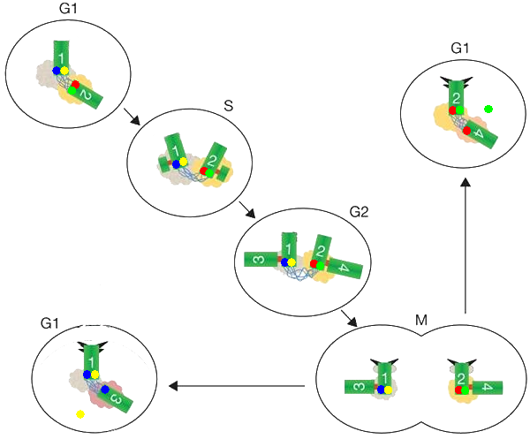
Figure 2. Asymmetric distribution of potential differentiation inducers into daughter cells during asymmetric division of mother cells. In the upper left corner of the image, a totipotent zygote/blast in the G1 phase is shown, containing de novo assembled centrioles labeled ‘1’ and ‘2’. For simplicity, differentiation inducers are shown quantitatively as two: a distinct pair of inducers is attached to each centriole. Each de novo assembled centriole likely contains different differentiation inducers, represented by blue and yellow for centriole 1, and red and green for centriole 2. During the division of the mother cell, different centrioles with corresponding differentiation inducers are incorporated into the daughter cells. Subsequently, the differentiation inducers are likely duplicated and released during the G1 phase of the daughter cells. During asymmetric division, differentiation inducers are presumably duplicated and attached to the newly formed (younger) daughter centriole. It is expected that the full complement of differentiation inducers will not be incorporated into the daughter centriole, with one inducer being detached, deactivating an active gene network and activating a different one.

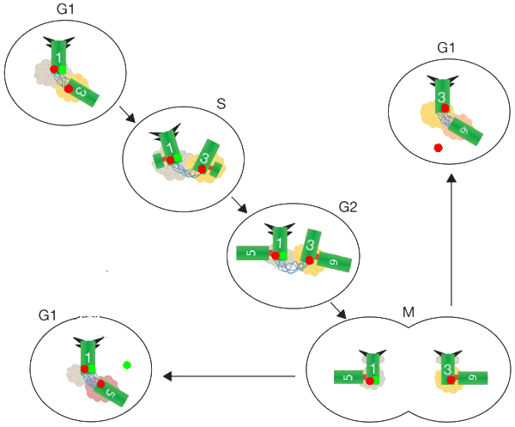
Figure 3. Asymmetric distribution of potential differentiation inducers into daughter cells during asymmetric division of mother cells—subsequent probable events. In the upper left corner of the image, a pluripotent cell in the G1 phase is depicted (with the ability for multiple differentiation potentials, depending on the associated inducers), where a previous asymmetric division has engaged a gene network, irreversibly deactivating the totipotency gene network and determining the differentiation fate of the subsequent daughter cells. The complete set of differentiation inducers is present on centriole 1, while centriole 3 is missing one inducer (due to failure to attach a differentiation inducer during duplication). After asymmetric division, one daughter cell, which retains the oldest centriole 1 and the full complement of differentiation inducers, forms a daughter centriole containing the same differentiation inducer as the mother cell. In the second daughter cell, only one differentiation inducer is present.

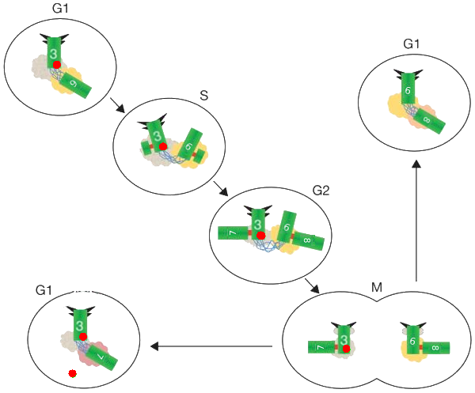
Figure 4. Asymmetric distribution of potential differentiation inducers into daughter cells during asymmetric division of mother cells—final probable events. In the upper left corner of the image, a unipotent cell in the G1 phase is shown (with only one differentiation potential based on its inducers), where the previous asymmetric division has activated a gene network. Centriole 3 carries only one differentiation inducer, and centriole 6 has no inducers at all. After asymmetric division, one daughter cell, possessing the oldest centriole 3 and a single differentiation inducer, forms a daughter centriole with the identical differentiation inducer as the mother cell. The second daughter cell does not possess any differentiation inducers, and no inducers are released—resulting in no differentiation and no change in its progeny. The programmed cell death-apoptosis status is reached in this cell's program or centrioles elimination/deactivation.

Temporal and Spatial Dynamics of Centriole Removal

The timeline of centriole elimination varies significantly across organisms and cell types. For instance: In C. elegans oocytes, elimination begins with the disassembly of the central tube and progresses to the loss of centriolar microtubules over several hours; In Drosophila, centriolar protein degradation spans up to 24 hours during oogenesis, while in eye development, the process takes over 60 hours, with ultrastructural changes occurring gradually; In differentiated C. elegans cells, the disappearance of centriolar foci can take anywhere from 95 to 185 minutes after the last mitotic division, depending on the cell type.

The subcellular location of centriole elimination also shows variability. In some cases, such as C. elegans neurons, centrioles migrate away from the nucleus before disassembly, suggesting a spatial component to the elimination mechanism. This raises intriguing questions about whether the nucleus provides a protective environment or if centriole removal is actively facilitated in distal cellular regions.

Centriole elimination is a multifaceted process with profound implications for gametogenesis, cellular differentiation, and organismal development. While its necessity in oogenesis is well-established, understanding its roles in somatic cells requires further investigation. Advancements in imaging and molecular tools will likely uncover the precise mechanisms and significance of this process, shedding light on its evolutionary and functional importance across cell types and organisms.

Selectivity in the Elimination of Centrioles

Is the elimination of centrioles a uniform process, or does it exhibit selectivity? In certain organisms, such as C. elegans during oogenesis, multiple pairs of centrioles and procentrioles are formed after the meiotic S phase, but all of them are eventually removed. Interestingly, in Drosophila oocytes, many more centrioles are inherited from the nurse cells than just four, yet they are all efficiently eliminated. This shows that centriole elimination can affect both centrioles and procentrioles, with the capacity to manage more than four organelles in some species. However, in starfish, the elimination mechanism targets only the daughter centrioles. Experimental manipulation in P. miniata shows that if the extrusion of the polar body is prevented, the mother centrioles are retained, but the daughter centrioles are eliminated. This highlights the specificity of the elimination process, which acts primarily on daughter centrioles in these species. Similarly, in A. forbesi (another species of starfish), while mother centrioles persist, they lose microtubule organizing activity. These findings suggest that centriole elimination mechanisms are versatile and can target all centrioles or selectively remove specific subsets depending on the species and cellular context.

Centriole Elimination During Polyspermy

In species like echinoderms, where centrioles are eliminated after meiosis, sperm-derived centrioles coexist in the cytoplasm with the daughter centrioles of the oocyte, which are scheduled for elimination. This prompts the question: how do sperm-derived centrioles avoid being eliminated upon fertilization? It is possible that the mechanism for centriole elimination works locally, distinguishing between maternally and paternally inherited centrioles, or that the two types of centrioles possess intrinsic differences that make them behave differently in the elimination process.

The phenomenon of physiological polyspermy further illustrates this selectivity. In species such as Cynops pyrrhogaster (a newt) and Beroe ovata (a comb jelly), multiple sperm fertilize the egg, but only two sperm-derived centrioles are retained, with the others being eliminated or inactivated. The question then arises: how is the choice made regarding which centrioles to maintain? One possibility is that the sperm centrioles that form asters are preferentially maintained, and the rest are removed. This could be tied to a process where the female pronucleus selectively interacts with microtubule-associated factors to stabilize and ensure the maintenance of only two centrioles. It is also conceivable that autophagy plays a role in the elimination of the unselected centrioles, as seen with accessory nuclei in polyspermy, where the surplus nuclei are marked for degradation. This process could involve the tagging of the unneeded centrioles for removal via autophagic pathways.

Mechanisms of Centriole Stability and Elimination

Centriole stability is remarkably high, making their elimination a complex process. Unlike the dynamic nature of cytoplasmic microtubules, which disassemble in response to cold or nocodazole treatment, centriolar microtubules remain stable and resist disassembly under these conditions. Even though the axoneme of primary cilia, derived from centrioles, is dynamic and disassembles each cell cycle, the centrioles themselves stay intact. This stability is evidenced by the fact that centrioles often persist long after sperm axonemes are incorporated into the zygote, or when centrioles are marked with fluorescent tags in embryos, indicating minimal turnover of their structural components over several cell cycles.

What mechanisms contribute to this high stability? One possibility is the unique structure of centriolar microtubules, which are typically organized into triplets or doublets. These structures might provide additional stability compared to the single protofilament microtubules of the cytoplasm. Additionally, certain tubulin isoforms, like δ- and ε-tubulin, are critical for the formation of stable triplets and doublets. Mutations in these tubulins result in unstable centrioles that disintegrate during cell division.

Another important aspect of centriole stability could involve specific stabilizing proteins. For instance, in human cells, proteins such as HsPOC1A, HsPOC1B, and CAP350 are believed to contribute to the structural integrity of centrioles. Other components, such as Centrobin, are thought to be specific to the daughter centrioles, and their removal can destabilize centrioles. Proteins like Bld10p in Chlamydomonas have been shown to stabilize triplet microtubules and ensure the proper assembly and maintenance of centrioles. Disrupting the function of these stabilizing proteins leads to the gradual loss of centrioles over time, which can be rescued by preventing protein degradation.

Understanding the dynamics of stabilizing proteins is crucial for understanding how centrioles are prepared for elimination. Some stabilizing proteins, such as HsPOC1A and HsPOC1B, exhibit turnover rates, suggesting that modulating their stability could prime centrioles for subsequent removal. Research into the turnover rates of centriole proteins could reveal how centrioles are “prepped” for elimination, possibly through changes in their post-translational modifications or their association with other degradation pathways like the proteasome. Thus, the interplay between centriole stability and the targeted elimination mechanisms remains an area ripe for exploration.

A crucial factor in maintaining centriole stability in C. elegans is SAS-1. Evidence for this comes from observations that centrioles derived from sas-1 mutant sperm rapidly lose their structural integrity post-fertilization. When maternal SAS-1 function is absent, centrioles initially form but subsequently degrade during embryogenesis. Recent studies have also identified SAS-1’s role in the elimination of centrioles during oogenesis. Here, SAS-1 departs from the centrioles earlier than other proteins, coinciding with the loss of the central tube, where SAS-1 is typically localized. Furthermore, in sas-1(t1521ts) mutants, centriolar microtubule signals and SAS-4 decay at an accelerated rate, leading to premature organelle disintegration. Interestingly, when expressed in human cells, C. elegans SAS-1 associates with and stabilizes microtubules. SAS-1 shares similarities with human C2CD3, a protein essential for centriole assembly and the formation of the primary cilium in mammals. Although the exact mechanisms by which SAS-1, and by extension C2CD3, contribute to centriole stability remain unclear, their structural arrangement—revealed by expansion microscopy to form a 9-fold radial symmetry within the microtubule wall—suggests they may function as an internal scaffold, maintaining the integrity of centriolar microtubules. Disruption of this scaffold could destabilize centrioles, offering potential targets for modulating organelle elimination.

Centriole stability is also influenced by post-translational modifications (PTMs) of α- and β-tubulin (figure 4a3–c3). Centriolar microtubules undergo a variety of PTMs, such as acetylation, detyrosinylation, and polyglutamylation, which are integral to their function. Injection of antibodies against polyglutamylated tubulin into human cells triggers centriole elimination, suggesting that these PTMs are essential for maintaining centriole structure. However, since antibody treatments can also induce protein degradation via the TRIM21 pathway, it remains uncertain whether the observed effects are due to the loss of PTMs or the complete removal of centriolar microtubules. Further studies will be necessary to determine whether targeted manipulation of microtubule PTMs specifically induces centriole elimination.

Factors Leading to Centriole Destabilization

Despite the widespread occurrence of centriole elimination, our understanding of the mechanisms behind it is still limited. Notable exceptions to this gap include studies conducted in C. elegans, which have identified key players involved in centriole assembly. Genome-wide screens utilizing RNA interference (RNAi) and forward genetic approaches have provided insight into evolutionarily conserved centriole assembly factors. These efforts, however, did not identify the expected phenotype associated with failed centriole elimination during oogenesis, such as the formation of a tetrapolar spindle in the first embryonic division. Several factors could explain this discrepancy: some relevant genes may not have been targeted due to their small size, lack of prediction, or resistance to RNAi depletion; redundant genes may have been overlooked; or the failure to eliminate centrioles during oogenesis may manifest earlier in the gonads, before detection in the embryo. Additionally, centrioles provided by the oocyte after the failure of centriole elimination factors might not function as microtubule organizing centers (MTOCs), complicating detection via differential interference contrast (DIC) microscopy.

Notably, in C. elegans, the heterochronic protein LIN-41 and the RNA helicase CGH-1 have been implicated in regulating the timing of centriole elimination during oogenesis, though their inhibition only delays—not prevents—this process. CGH-1 likely affects the stability of an mRNA encoding a protein that promotes centriole elimination. Furthermore, the XX karyotype seems to influence centriole elimination during oogenesis, as late prophase I oocytes from mutant males with female gonads still harbor centrioles. The molecular factors associated with this karyotypic influence remain unknown. In the case of C. elegans intestinal centriole elimination, a combination of PLK-1-mediated phosphorylation of the PCM protein SPD-2, repression of centriole biogenesis genes, and proteasomal degradation have been proposed to facilitate centriole loss.

One hypothesis is that centriole elimination is initiated by shutting down stabilizing mechanisms, such as the removal of the PCM (pericentriolar material). In Tetrahymena, depletion of the PCM component γ-tubulin destabilizes centrioles. Similarly, in Drosophila cells arrested in S-phase, depletion of several PCM components, such as Asl, D-Plp, Spd2, and Cnn, results in centriole loss. During Drosophila oogenesis, Polo kinase is released from the PCM before its removal, and expression of a centriolar-targeting Polo fusion protein prevents centriole degradation beyond fertilization. While the absence of electron microscopy data makes it unclear whether the resulting supernumerary foci represent centrioles or merely centriolar protein assemblies, these observations suggest a role for Polo and PCM removal in centriolar destabilization. However, similar mechanisms do not seem to universally govern centriole elimination across other species, as in the case of A. forbesi, where retained mother centrioles fail to nucleate microtubules.

While Polo and PCM removal are critical in Drosophila, other organisms may employ different strategies for centriole destabilization.

Discussion

Although many mechanisms of elimination of centrioles remain to be fully elucidated, we now have a clearer understanding of when and where centrioles are eliminated and an increasing number of tools to probe this process further.

To uncover the molecular details of centriole elimination, dedicated screens targeting this phenomenon will be essential. Genome-scale screens using CRISPR/Cas9, RNAi, or mutant libraries that identify conditions where centriole elimination is either delayed or accelerated will be critical for uncovering new players in this process. Since centriole architecture and assembly mechanisms are conserved across eukaryotic species, insights gained from diverse organisms will likely provide a more comprehensive understanding of centriole elimination.

The origin of centrioles remains unclear. Some theories suggest that centrioles evolved from viruses that have since gone extinct, given the structural similarities between viral capsids and centrioles. Adenoviruses, for example, employ diverse strategies to uncoat their protein capsids within host cells, including conformational changes induced by pH and interactions with microtubule motor proteins. These processes could potentially offer insights into the mechanisms that regulate centriole elimination

While much remains to be learned, understanding how centrioles are eliminated in different organisms could have broad implications for developmental biology, disease mechanisms, and therapeutic development.

Conclusion

This review proposes a detailed model for the asymmetric distribution of centrioles during stem cell division, emphasizing their role in the regulation of differentiation. By observing how centrioles, specifically the mother and newly assembled daughter centrioles, contribute to the segregation of differentiation inducers, observe the critical role of centrioles in guiding the fate of daughter cells. The asymmetric distribution of centrioles and their associated differentiation signals is integral to ensuring that one daughter cell retains stemness while the other is pushed toward differentiation.

The findings support the hypothesis that centrioles are not merely structural components but also key players in cellular decision-making. The selective attachment of differentiation inducers to centrioles suggests a mechanism by which stem cells maintain their potential for self-renewal or differentiation, depending on the centrosome inheritance. Furthermore, this model emphasizes the complex nature of centriole elimination, showing that it is intricately linked to the regulation of gene networks that dictate cell fate. This hypothesis calls for future research to further elucidate the molecular interactions between centrioles, differentiation inducers, and the broader genetic networks involved. Understanding these processes could provide important insights into stem cell biology, offering new perspectives for therapeutic applications such as regenerative medicine and the treatment of diseases involving stem cell dysfunction.

References:

- Chichinadze, K., Lazarashvili, A., & Tkemaladze, J. (2013). RNA in centrosomes: structure and possible functions. Protoplasma, 250(1), 397-405.
- Chichinadze, K., Tkemaladze, J., & Lazarashvili, A. (2012). A new class of RNAs and the centrosomal hypothesis of cell aging. Advances in Gerontology, 2(4), 287-291.
- Chichinadze, K., Tkemaladze, J., & Lazarashvili, A. (2012). Discovery of centrosomal RNA and centrosomal hypothesis of cellular ageing and differentiation. Nucleosides, Nucleotides and Nucleic Acids, 31(3), 172-183.
- Chichinadze, K., Tkemaladze, D., & Lazarashvili, A. (2012). New class of RNA and centrosomal hypothesis of cell aging. Advances in Gerontology= Uspekhi Gerontologii, 25(1), 23-28.
- Chichinadze, K. N., & Tkemaladze, D. V. (2008). Centrosomal hypothesis of cellular aging and differentiation. Advances in Gerontology= Uspekhi Gerontologii, 21(3), 367-371.
- Gambarotto, D., Zwettler, F., Cernohorska, M.S., Fortun, D., Borgers, S., Heine, J., Schloetel, J., Reuss, M., Unser, M.A., Boyden, E.S., Sauer, M., Hamel, V., & Guichard, P. (2018). Imaging beyond the super-resolution limits using ultrastructure expansion microscopy (UltraExM). bioRxiv.
- Jaba, T. (2022). Dasatinib and quercetin: short-term simultaneous administration yields senolytic effect in humans. Issues and Developments in Medicine and Medical Research Vol. 2, 22-31.
- Kipshidze, M., & Tkemaladze, J. (2024). Abastumani Resort: Balneological Heritage and Modern Potential. Junior Researchers, 2(2), 126–134. doi: https://doi.org/10.52340/jr.2024.02.02.12
- Kipshidze, M., & Tkemaladze, J. (2024). Microelementoses - history and current status. Junior Researchers, 2(2), 108–125. doi: https://doi.org/10.52340/jr.2024.02.02.11
- Kipshidze, M., & Tkemaladze, J. (2023). The planaria Schmidtea mediterranea as a model system for the study of stem cell biology. Junior Researchers, 1(1), 194–218. doi: https://doi.org/10.52340/2023.01.01.20
- Kipshidze, M., & Tkemaladze, J. (2023). Comparative Analysis of drugs that improve the Quality of Life and Life Expectancy. Junior Researchers, 1(1), 184–193. doi: https://doi.org/10.52340/2023.01.01.19
- Kipshidze, M., & Tkemaladze, J. (2024). Balneology in Georgia: traditions and modern situation. Junior Researchers, 2(2), 78–97. doi: https://doi.org/10.52340/jr.2024.02.02.09
- Lezhava, T., Monaselidze, J., Jokhadze, T., Kakauridze, N., Khodeli, N., Rogava, M., Tkemaladze, J., ... & Gaiozishvili, M. (2011). Gerontology research in Georgia. Biogerontology, 12, 87-91. doi: 10.1007/s10522-010-9283-6. Epub 2010 May 18. PMID: 20480236; PMCID: PMC3063552
- Matsaberidze, M., Prangishvili, A., Gasitashvili, Z., Chichinadze, K., & Tkemaladze, J. (2017). TO TOPOLOGY OF ANTI-TERRORIST AND ANTI-CRIMINAL TECHNOLOGY FOR EDUCATIONAL PROGRAMS. International Journal of Terrorism & Political Hot Spots, 12.
- Prangishvili, A., Gasitashvili, Z., Matsaberidze, M., Chkhartishvili, L., Chichinadze, K., Tkemaladze, J., ... & Azmaiparashvili, Z. (2019). SYSTEM COMPONENTS OF HEALTH AND INNOVATION FOR THE ORGANIZATION OF NANO-BIOMEDIC ECOSYSTEM TECHNOLOGICAL PLATFORM. Current Politics and Economics of Russia, Eastern and Central Europe, 34(2/3), 299-305.
- Tkemaladze, J. (2024). The rate of stem cell division decreases with age. Georgian Scientists, 6(4), 228–242. doi: https://doi.org/10.52340/gs.2024.06.04.21
- Tkemaladze, J. (2024). Absence of centrioles and regenerative potential of planaria. Georgian Scientists, 6(4), 59–75. doi: https://doi.org/10.52340/gs.2024.06.04.08
- Tkemaladze, J. (2024). Main causes of intelligence decrease and prospects for treatment. Georgian Scientists, 6(2), 425–432. doi: https://doi.org/10.52340/gs.2024.06.02.44
- Tkemaladze, J. (2024). Cell center and the problem of accumulation of oldest centrioles in stem cells. Georgian Scientists, 6(2), 304–322. doi: https://doi.org/10.52340/gs.2024.06.02.32
- Tkemaladze, J., & Samanishvili, T. (2024). Mineral ice cream improves recovery of muscle functions after exercise. Georgian Scientists, 6(2), 36–50. doi: https://doi.org/10.52340/gs.2024.06.02.04
- Tkemaladze J. Editorial: Molecular mechanism of ageing and therapeutic advances through targeting glycative and oxidative stress. Front Pharmacol. 2024 Mar 6;14:1324446. doi: 10.3389/fphar.2023.1324446. PMID: 38510429; PMCID: PMC10953819.
- Tkemaladze, Jaba and Kipshidze, Mariam, Regeneration Potential of the Schmidtea Mediterranea CIW4 Planarian. Available at SSRN: https://ssrn.com/abstract=4633202 or http://dx.doi.org/10.2139/ssrn.4633202
- Tkemaladze, J. (2023). Is the selective accumulation of oldest centrioles in stem cells the main cause of organism ageing?. Georgian Scientists, 5(3), 216–235. doi: https://doi.org/10.52340/2023.05.03.22
- Tkemaladze, J. (2023). Cross-senolytic effects of dasatinib and quercetin in humans. Georgian Scientists, 5(3), 138–152. doi: https://doi.org/10.52340/2023.05.03.15
- Tkemaladze, J. (2023). Structure and possible functions of centriolar RNA with reference to the centriolar hypothesis of differentiation and replicative senescence. Junior Researchers, 1(1), 156–170. doi: https://doi.org/10.52340/2023.01.01.17
- Tkemaladze, J. (2023). The centriolar hypothesis of differentiation and replicative senescence. Junior Researchers, 1(1), 123–141. doi: https://doi.org/10.52340/2023.01.01.15
- Tkemaladze, J. (2023). Reduction, proliferation, and differentiation defects of stem cells over time: a consequence of selective accumulation of old centrioles in the stem cells?. Molecular Biology Reports, 50(3), 2751-2761.
- Tkemaladze, J. Long-Term Differences between Regenerations of Head and Tail Fragments in Schmidtea Mediterranea Ciw4. Available at SSRN 4257823.
- Tkemaladze, J., & Apkhazava, D. (2019). Dasatinib and quercetin: short-term simultaneous administration improves physical capacity in human. J Biomedical Sci, 8(3), 3.
- Tkemaladze, J., Tavartkiladze, A., & Chichinadze, K. (2012). Programming and Implementation of Age-Related Changes. In Senescence. IntechOpen.
- Tkemaladze, J., & Chichinadze, K. (2010). Centriole, differentiation, and senescence. Rejuvenation research, 13(2-3), 339-342.
- Tkemaladze, J. V., & Chichinadze, K. N. (2005). Centriolar mechanisms of differentiation and replicative aging of higher animal cells. Biochemistry (Moscow), 70, 1288-1303.
- Tkemaladze, J., & Chichinadze, K. (2005). Potential role of centrioles in determining the morphogenetic status of animal somatic cells. Cell biology international, 29(5), 370-374.
- Прангишвили, А. И., Гаситашвили, З. А., Мацаберидзе, М. И., Чичинадзе, К. Н., Ткемаладзе, Д. В., & Азмайпарашвили, З. А. (2017). К топологии антитеррористических и антикриминальных технологии для образовательных программ. В научном издании представлены материалы Десятой международной научно-технической конфе-ренции «Управление развитием крупномасштабных систем (MLSD’2016)» по следующим направле-ниям:• Проблемы управления развитием крупномасштабных систем, включая ТНК, Госхолдин-ги и Гос-корпорации., 284.
- Ткемаладзе, Д., Цомаиа, Г., & Жоржолиани, И. (2001). Создание искусственных самоадаптирующихся систем на основе Теории Прогноза. Искусственный интеллект. УДК 004.89. Искусственный интеллект. УДК 004.89.
- Чичинадзе, К., Ткемаладзе, Д., & Лазарашвили, А. (2012). НОВЫЙ КЛАСС РНК И ЦЕНТРОСОМНАЯ ГИПОТЕЗА СТАРЕНИЯ КЛЕТОК. Успехи геронтологии, 25(1), 23-28.

